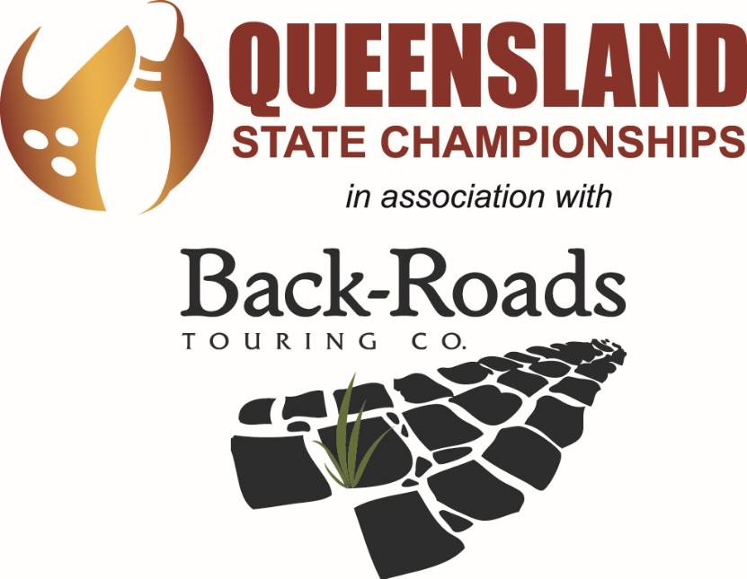
Hosted At
Mari Street Alexandra Headland
Saturday 21st and Sunday 22nd March
Friday 27th^{th}, Saturday 28th, Sunday 29th March
Including Restricted Cup, Seniors Cup, Youth Cup & Queensland State Masters
TBA Accreditation No.____________

Saturday 21st March
Squad A Check-in 9.00am
Squad B Check-In 1.00pm
Sunday 22nd March
Squad C Check-in 8.30am
Queensland Restricted Masters 11.30am
Friday 27th March
Squad Z Check-in 6.00pm (if required)
Saturday 28th March
Squad D Check-in 7.45am
Queensland Youth Masters 11.45am
Queensland Seniors Masters 11.45am
TBAQ State AGM – 2.00pm
Local Association and State Committees Q and A 3.00pm
TBAQ Awards Presentation & Hall of Fame Ceremony – 6.30 pm for 7.00pm Start
“Celebrating our Sporting Athletes and honouring our volunteers.”

Venue TBA
Email: tbaq@tbaq.org.au
Dress: Smart casual.
Sunday 29st March
Queensland Open Masters 8.30am

Championships Schedule
(each squad limited to 12 teams of 4 bowlers per team):

Squad times: A-Squad– Check-in 9:00 am, Saturday 21st March
B-Squad– Check-in 1:00 pm, Saturday 21st March
C-Squad– Check-in 8:30 am, Saturday 22nd March
D-Squad– Check-in 7:45 am, Saturday 28th March

Z-Squad– Check-in 5:45 pm, 27th March (if Required)

Championships entry fee: $135.00 (breakdown: $45.00 lineage; $17.50 masters; $12.50 all events; $12.50 Admin fee; $47.50.00 prize fund each division).
Championships entries are four-man teams. Each participant will complete nine games in each squad, with the first three-game block consisting of their singles entry; the second game block consisting of their doubles entry and the final three-game block consisting of four-man teams (with each four-man team moving lanes together).
GRADINGS: Based on averages submitted, entries are graded into the appropriate division. A bowler may, however, nominate to compete in a division above their classification.

Division | Singles & All Events |  | Doubles
 | Men | Women | Men | Women
1 | 205 + | 195 + | 410 + | 390 +
2 | 190 - 204 | 180 - 194 | 380-409 | 360-389
3 | 175 - 189 | 165 - 179 | 350-379 | 330-359
4 | 160 - 174 | 150 - 164 | 320-349 | 300-329
5 | 159 & Below | 149 & Below | 319 & Below | 299 & Below
Division | Teams |  | Mixed Doubles | Mixed Teams
 | Men | Women
1 | 817 + | 776 + | 400 + | 790 +
2 | 760 – 816 | 720-775 | 370-399 | 740-799
3 | 700 – 759 | 660-719 | 340-369 | 680-739
4 | 640 - 699 | 600 - 659 | 310 -339 | 620- 679
5 | 639 & below | 599 & below | 309 & below | 619 & below

2020 QUEENSLAND RESTRICTED CUP

Final: Sunday 22th March 2020.
Cost: $95.00
Check-in: 11:45am
Commence play: 12:30pm
Cut Off Averages: Men: 184 or less
Women: 174 or less.

All Bowlers, including the 2019 defending Queensland Restricted Cup champions and local association champions (if eligible) MUST have completed an all events entry to qualify for the 2020 Restricted Cup final. If you are a local association Masters Champion, please notify the tournament team of this and ensure that your local association has paid for your entry (if applicable) before arriving at the tournament room.
Please note that this is a handicap event, and handicaps will be taken into account for both qualifying and finals. Handicap: 100% of 200. See General Rules for requirements about proof of average.

FORMAT:
Stage 1
The top twelve restricted men and top twelve restricted ladies (including defending champions and local champions, if applicable) will complete eight games. At the end of this stage, the top six men and six ladies on accumulated pinfall with a handicap will progress to match play.
Stage 2
The top six men and six ladies will complete five games of match play, with 30 for a win and 15 for a loss. At the conclusion of the five games, the bowler with the highest pinfall with handicap and bonus pins will be the 2020 Restricted Masters Champion.

Both male and female winners will receive a minimum $250.00, plus a 2020 Masters shirt, paid entry into the 2020 National Restricted Cup (average allowing) and an unpaid spot in the 2021 Queensland Restricted Cup (please note a qualifying all events entry will still be required). **Winners are responsible for their own travel and accommodation requirements and qualifying responsibilities when participating in the National events**

** Ties for the final qualifying positions will be decided by a one game roll off. In the event of a tie after the five games match play a single game will be bowled.
2020 QUEENSLAND SENIORS CUP

Final: Saturday 28th March 2020.
Cost: $95.00
Check-in: 11:45am
Commence play: 12:30pm

All Bowlers, including the 2019 defending Queensland Seniors Cup champions and local association champions (if eligible) MUST have completed an all events entry to qualify for the 2020 Seniors Cup final. If you are a local association Masters Champion, please notify the tournament team of this and ensure that your local association has paid for your entry (if applicable) before arriving at the tournament room.
Please note that this is a SCRATCH event.
Bowlers wishing to contest the Queensland Seniors Cup title must attain the age of 50 during the year 2020.

FORMAT:
Stage 1
The top 10 Senior men and top 10 senior ladies (including defending champions and local champions, if applicable) will complete eight games. At the end of this stage, the top six men and six ladies on accumulated pinfall will progress to match play.
Stage 2
The top six men and six ladies will complete five games of match play, with 30 for a win and 15 for a loss. At the conclusion of the five games, the bowler with the highest pinfall with bonus pins will be the 2020 Senior Masters Champion.

Both male and female winners will receive a minimum $250.00, plus a 2020 Masters shirt, paid entry into the 2020 National Seniors Cup and an unpaid spot in the 2021 Queensland Seniors Cup (please note a qualifying all events entry will still be required). **Winners are responsible for their own travel and accommodation requirements and qualifying responsibilities when participating in the National events**

** Ties for the final positions will be decided by a one game roll off. A 10th frame replay will decide tied matches after that.
2020 QUEENSLAND STATE OPEN MASTERS

Final: Sunday 29th March 2020.
Cost: Men: $150.00
Women: $ 95.00
Check-in: 7:45am
Commence play: 8:00am
Open to all female and male bowlers.

FORMAT:
Stage 1:
The top 20 male qualifiers will bowl six games, two to a pair, changing lanes after each game.

Stage 2:
The top 10 females and the top 10 men for stage one will bowl six games with carried pinfall. The top eight men and eight ladies on pinfall will progress to the elimination final

Elimination Final:
The Top eight men and eight women will bowl three rounds of elimination matches, best of three games, to decide the 2019 Open Masters Champion.

Round 1: Q1 Vs Q8 Q2 Vs Q7 Q3 Vs Q6 Q4 Vs Q5

Round 2: Winner Q1Q8 Vs Winner Q4Q5
Winner Q2Q7 Vs Winner Q3Q6

Final Winner Q1Q8Q4Q5 Vs Winner Q2Q7Q3Q6

The winner of the final match will be the 2020 Queensland Open Masters Champion.
** Ties will be decided by an additional game till broken

The men’s winner will receive a minimum of $500.00 with the women’s division winner receiving a minimum of $400.00. Both winners also receive a 2020 Masters shirt, paid entry into the 2020 Australian Open Masters, and an unpaid spot as the defending champion in the 2021 State Open Masters tournament. (please note a qualifying all events entry will still be required). **Winners are responsible for their own travel and accommodation requirements and qualifying responsibilities when participating in the National events**

2020 QUEENSLAND YOUTH MASTERS

Final: Saturday 28th March 2020.
Cost: $95.00
Check-in: 11:45am
Commence play: 12:30pm

Bowlers wishing to contest the Queensland Youth Masters must not be older than 21 years of age as at the 1st of January 2020

FORMAT:
Stage 1
The top 10 Youth Men and top 10 Youth Ladies will bowl nine games match play. 30 bonus pins for a win and 15 for a draw will be allocated to the bowlers scratch pinfall. At the conclusion of the eleven games, the bowler on the highest scratch pinfall plus bonus pin will be declared the Champion 2020 Youth Masters Champion

** Ties for the final position will be decided by a one game roll off. A 10th frame replay will decide tied matches after that.

GENERAL RULES & REGULATIONS:
- Tenpin Bowling Australia Limited Rules and Regulations will govern this tournament.
- This tournament is open to all 2020 TBA registered players aged 14 as at 1 January 2020 and residing in Queensland (including Tweed Heads)
- Southern Queensland Bowlers MUST have completed an all events entry in 2020 Queensland State Championships at Sunset. Northern Queensland Bowlers must complete a local or zone championships. Proof of participation is required with entry forms. If you are unable to participate in the required championships, you will require an exemption to bowl in your local area championships if you wish to attend the state trials.
- Entering Averages: Highest league average over a minimum of 24 games as at 31st December 2019

- . Bowlers submitting an average must also submit proof of average verified by their League Secretary or Centre Managers’ signature. Averages may be verified with failure to disclose correct averages resulting in disqualification.
- Dress Code: All bowlers are required to wear neat, suitable attire at all times. Collared bowling shirts, trousers, tailored shorts or skirts are preferred. Men may wear Tailored shorts during All Event Squads. However long trousers must be worn for Masters.(Torn or dirty clothing, singlets, leggings, bike shorts, Cargos, Board Shorts, Denim or T-Shirts are NOT permitted) Bowlers may not wear hats or caps while bowling. THIS DRESS CODE WILL BE STRICTLY ENFORCED.
- A bowler’s’ best three-game block in each event will count toward his or her all-events score in the division that their singles scores are entered in. A bowler must have completed an All Events to qualify for a Masters Final. Masters qualifying will be based on the bowler’s best two blocks of three games in any championships event.
- Substitutes and changes in the lineup must be given to Tournament control at least one hour before the scheduled time to bowl.
- All entrants must check in at Tournament control at least 30 minutes before the start of the squad. Squads may commence earlier than advertised if lanes are conditioned, and all bowlers are present.
- In the case of a tie for first place, Co-champions will be declared.
- No team or individual shall be entitled to a refund after receipt of entry unless a Medical Certificate is supplied.
- FULL ENTRY FEES MUST ACCOMPANY ALL ENTRIES. Incomplete or incorrect entries will not be accepted.
- NO SMOKING OR CONSUMPTION OF ALCOHOL is permitted for the duration of the squad.
- The use of electronic devices such as mobile phones excluding headphones/headsets) is only permitted if this use does not delay play. Such devices must be on silent and any player causing slow play will receive a yellow card. A second infringement will incur a red card and disqualification from the tournament resulting in non-eligibility for any team
- Un-Sportsperson like conduct will not be tolerated.
- The Tournament Committee and TBAQ will decide any matters which may arise and are not covered by the above rules.
- All participants are advised that they must provide their bank account details to the Tournament Committee before the end of the tournament, as ALL prizes for the Queensland State Championships will be paid via Direct Deposit. CHEQUES WILL NOT BE SENT.
- PRIZES: If there are 1 to 10 entries (per division) there will be only one prize - the winner receives 100% of that division’s prize fund. If there are 11 to 20 entries, there will be two prize payments made - first place receives 65% and second place receives 35% of the monies in that division prize fund. If there are 21 to 30 entries, there will be three prize payments made - first place will receive 60%, second place 27% and third place 13% of monies in that division's prize fund.

BOWLER REGISTRATION FORM – PAGE 1 OF 2
Please note: Any form that has not been fully completed including all bank details will not be processed by the tournament team in anyway. Your entry will not be valid until these details are received as all prize money will be deposited via eft to your nominated account. NO EXCEPTIONS.

BOWLER 1: (MAIN CONTACT FOR TEAM) NB: Bowlers 1 and 2 will be paired for doubles, as will bowlers 3 and 4.
Name: |  | Local Association:
TBA No.: | Email:
Please circle: Male Female | Date of birth: |  | Average @ 31/12/19:
Phone No.: | Mobile: |  | League Standing Sheet Attached?
Bank account name: |  | Bank:
BSB: |  | Account No:

BOWLER 2:
Name: |  | Local Association:
TBA No.: | Email:
Please circle: Male Female | Date of birth: |  | Average @ 31/12/19:
Phone No.: | Mobile: |  | League Standing Sheet Attached?
Bank account name: |  | Bank:
BSB: |  | Account No:

BOWLER 3:
Name: |  | Local Association:
TBA No.: | Email:
Please circle: Male Female | Date of birth: |  | Average @ 31/12/19:
Phone No.: | Mobile: |  | League Standing Sheet Attached?
Bank account name: |  | Bank:
BSB: |  | Account No:
BOWLER REGISTRATION FORM – PAGE 2 OF 2

BOWLER 4:
Name: |  | Local Association:
TBA No.: | Email:
Please circle: Male Female | Date of birth: |  | Average @ 31/12/19:
Phone No.: | Mobile: |  | League Standing Sheet Attached?
Bank account name: |  | Bank:
BSB: |  | Account No:

SQUAD PREFERENCE:
PLEASE INDICATE BY MARKING 1 – 4 IN THE BOXES PROVIDED. Squads will be filled on a first come, first served basis. C Squad will be reserved for those bowlers who have travelled to participate. It will be opened up to local bowlers for last minute entries.
A SQUAD SATURDAY 21st March 9.30AM CHECK-IN 9.00AM
B SQUAD SATURDAY 21st March 1.30PM CHECK-IN 1.00pm
C SQUAD SATURDAY 28th March 8.00AM CHECK-IN 7.45AM
Z SQUAD Friday 29th March 6.00PM CHECK-IN 5.45PM

PAYMENT IS TO BE IN FULL WITH NOMINATION. PLEASE PROVIDE PROOF OF PAYMENT, OR YOUR ENTRY WILL NOT BE PROCESSED. BANK DETAILS FOR PAYMENT ($135.00 PER PERSON, $550.00 PER TEAM) Email: adultcommittee@tbaq.org.au or morty@rd8.net.au
BANK OF QUEENSLAND,
BSB: 124 001 Account number: 13261021
Account Name: TBAQ SQ Tournament Account
Reference: Bowler #1 Name

